**Experiment No: 2**

**Title:** Configure web server and launch web application over the virtual machine.

**Aim**: To run a web server in virtual machine to launch a web application.

**Theory:**

**Web Server:**

A web server is software and hardware that uses HTTP (Hypertext Transfer Protocol) and other protocols to respond to client requests made over the World Wide Web. The main job of a web server is to display website content through storing, processing and delivering webpages to users. Besides HTTP, web servers also support SMTP (Simple Mail Transfer Protocol) and FTP (File Transfer Protocol), used for email, file transfer and storage.

Web server hardware is connected to the internet and allows data to be exchanged with other connected devices, while web server software controls how a user accesses hosted files. The web server process is an example of the client/server model. All computers that host websites must have web server software.

Web servers are used in web hosting, or the hosting of data for websites and web-based applications -- or web applications.

To publish a website, you need either a static or a dynamic web server.

A static web server, or stack, consists of a computer (hardware) with an HTTP server (software). We call it "static" because the server sends its hosted files as-is to your browser.

A dynamic web server consists of a static web server plus extra software, most commonly an application server and a database. We call it "dynamic" because the application server updates the hosted files before sending content to your browser via the HTTP server.

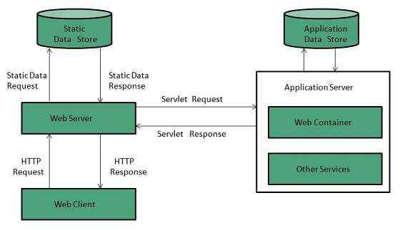

**Apache Web Server:**

Apache is a popular open-source, cross-platform web server that is, by the numbers, the most popular web server in existence. It’s actively maintained by the Apache Software Foundation.

Although we call Apache a web server, it is not a physical server, but rather a software that runs on an HTTP server. Its job is to establish a connection between a server and the browsers of website visitors (Firefox, Google Chrome, Safari, etc.) while delivering files back and forth between them (client-server structure). The Apache software is also compatible with any operating system, from Windows to Unix.

The server and the client communicate through the HTTP protocol, and the Apache web server is responsible for the smooth and secure communication between the two machines.

Apache provides plenty of modules that allow server administrators to turn additional functionalities on and off. The Apache web server has modules for security, caching, URL rewriting, password authentication, and other features.

**Practical:**

Step 1: created the virtual machine and installed the httpd web server.

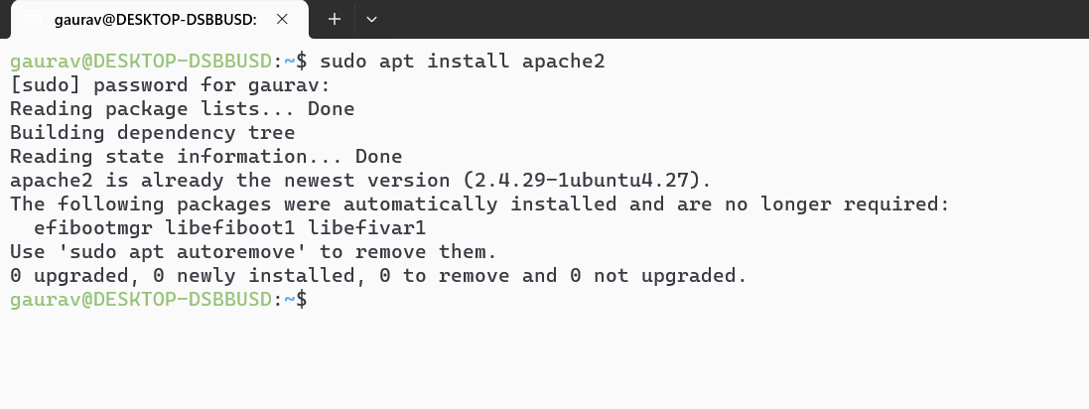

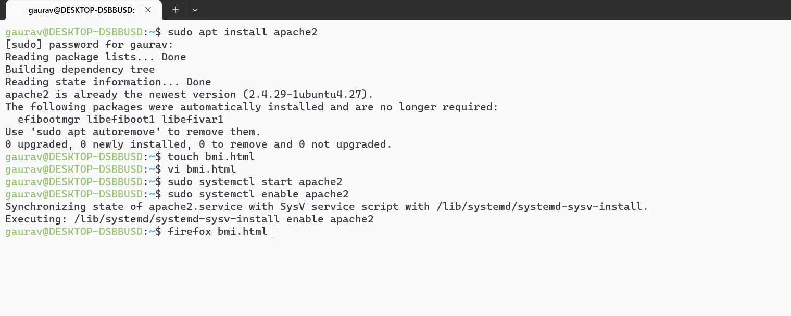

Step 2:Create the .html file

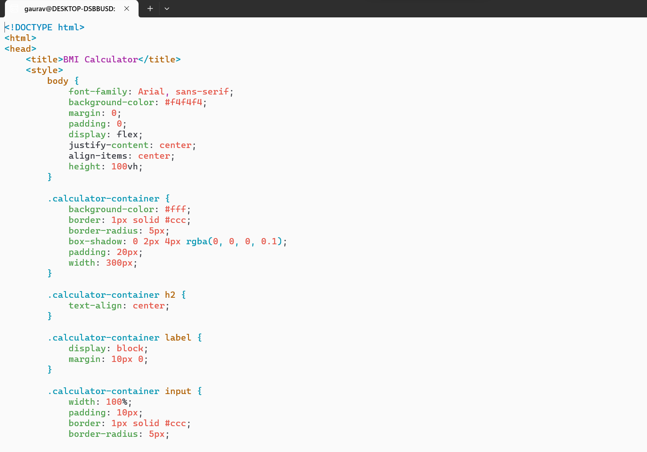

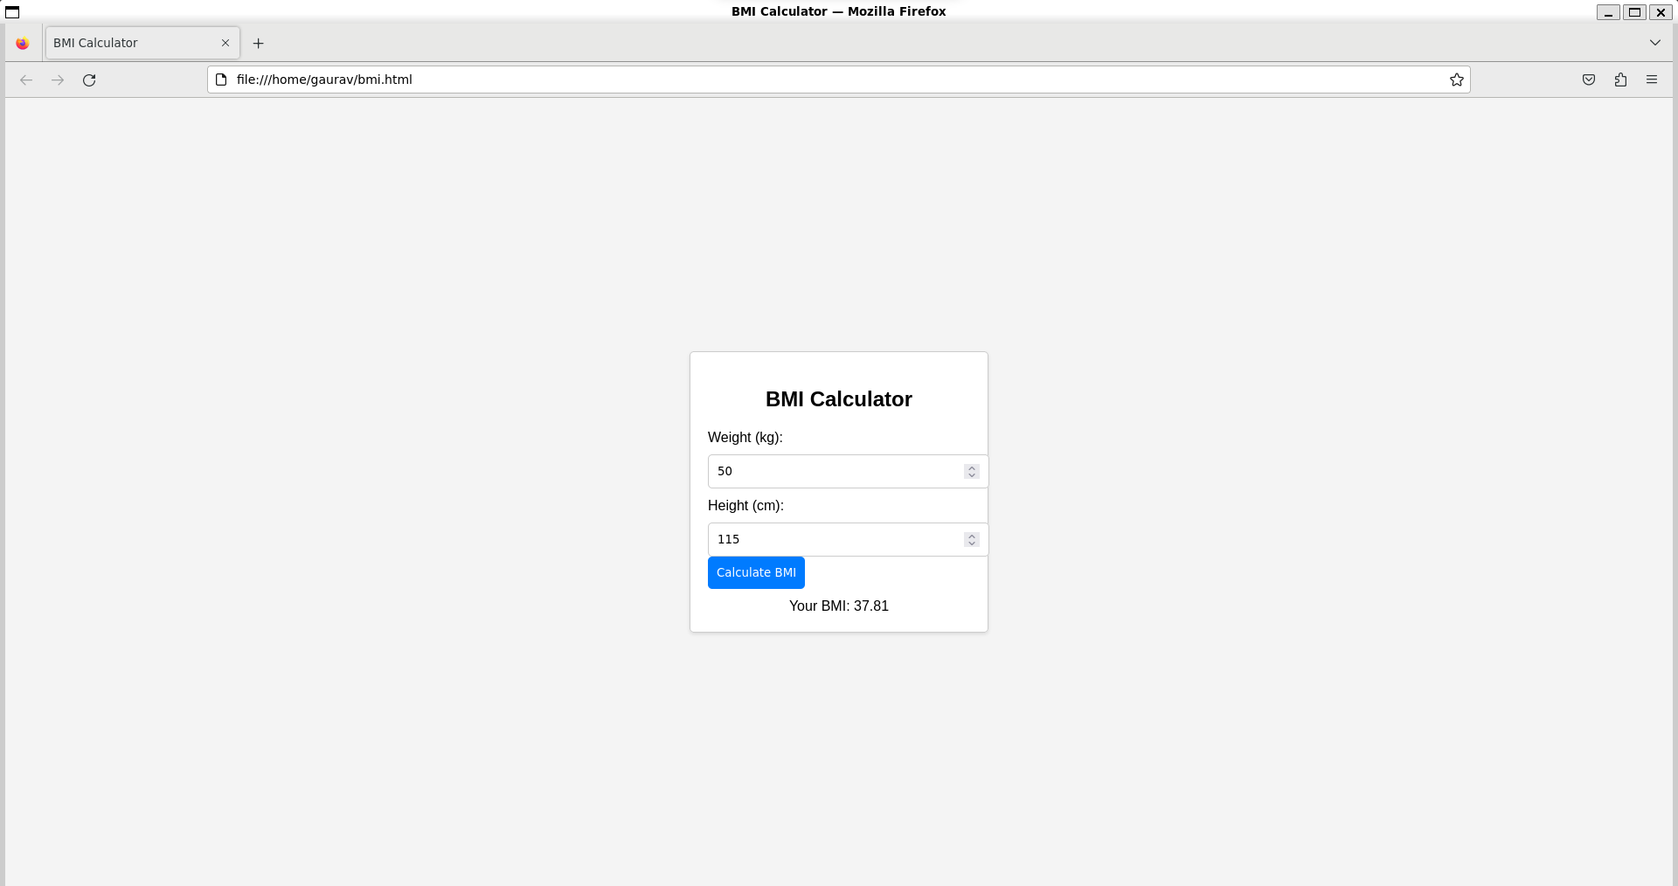

**Conclusion:**

Thus, I configured web server and launched web application over the virtual machine.